March 2, 2018

Ms. Seema Verma Administrator

Centers for Medicare and Medicaid Services 200 Independence Ave SW

Washington, DC 20201

Docket Number CMS-2017-0163

Submitted Electronically to www.regul at ions.gov Dear Administrator Verma:

# Personal

**11J Connected**

CJ

# Health

Alliance

We appreciate the opportunity to provide comments on "Advance Notice of Methodological Changes for Calendar Year (CY) 2019 for Medicare Advantage (MA) Capitation Rates, Part C and Part D Payment

Policies and 2019 draft Call Letter", released on February 1, 2018. Our comments focus on the need for the 2019 Call Letter to align Medicare Part Band MA plan coverage for chronic condition remote monitoring . We request that CMS provide clarification that chronic condition remote monitoring is a basic benefit in the 2019 Call Letter and modify the supplemental benefits section of the "Medicare Managed Care Manual, Chapter 4 - Benefits and Beneficiary Protections" to eliminate further co nfusion.

***The Issue: Disconnect between Part B coverage and MA Organization Instructions re: remote monitoring***

We appreciate that over the last four years, CMS has issued several important proposals that embrace innovative technology delivery mechanisms. Starting with the addition of the Transitional Care Management Codes in the 2013 Physician Fee Schedule, the proposal in the 2015 Physician Fee Schedule to provide coverage for non-face-to-face complex care management (CCM) services for Medicare beneficiaries who have two or more chronic conditions that make use of 21st century information communication technologies or remote access technologies to conduct CCM, and most recently, coverage for "collection and interpretation of stored patient data by a physician or qualified health professional" through CPT code 990911 .

CMS publicly noted, in the standards for CCM, that remote monitoring is an acceptable and permitted information communication technology (ICT) or remote access technology for chronic care

management2 (see next page for screen shot of Federal Register Notice.) In announcing significant policy updates contained in the CY2018 Medicare physician fee schedule rule, CMS stated it would cover "review of stored patient data by a health professional" as of January 1, 20183 (see next page for screenshot of press release) .

1 Federal Register IVol. 79, No. 219 !Thursday, November 13, 2014 I page 67727.

2 Ibid

3 Federal Register I Vol. 82, No. 219 I Wednesday, November 15, 2017 I page 55013-14.

Federal Regist er / Vol. 79, No. 219 / Thursd ay, November 13, 2014 ,

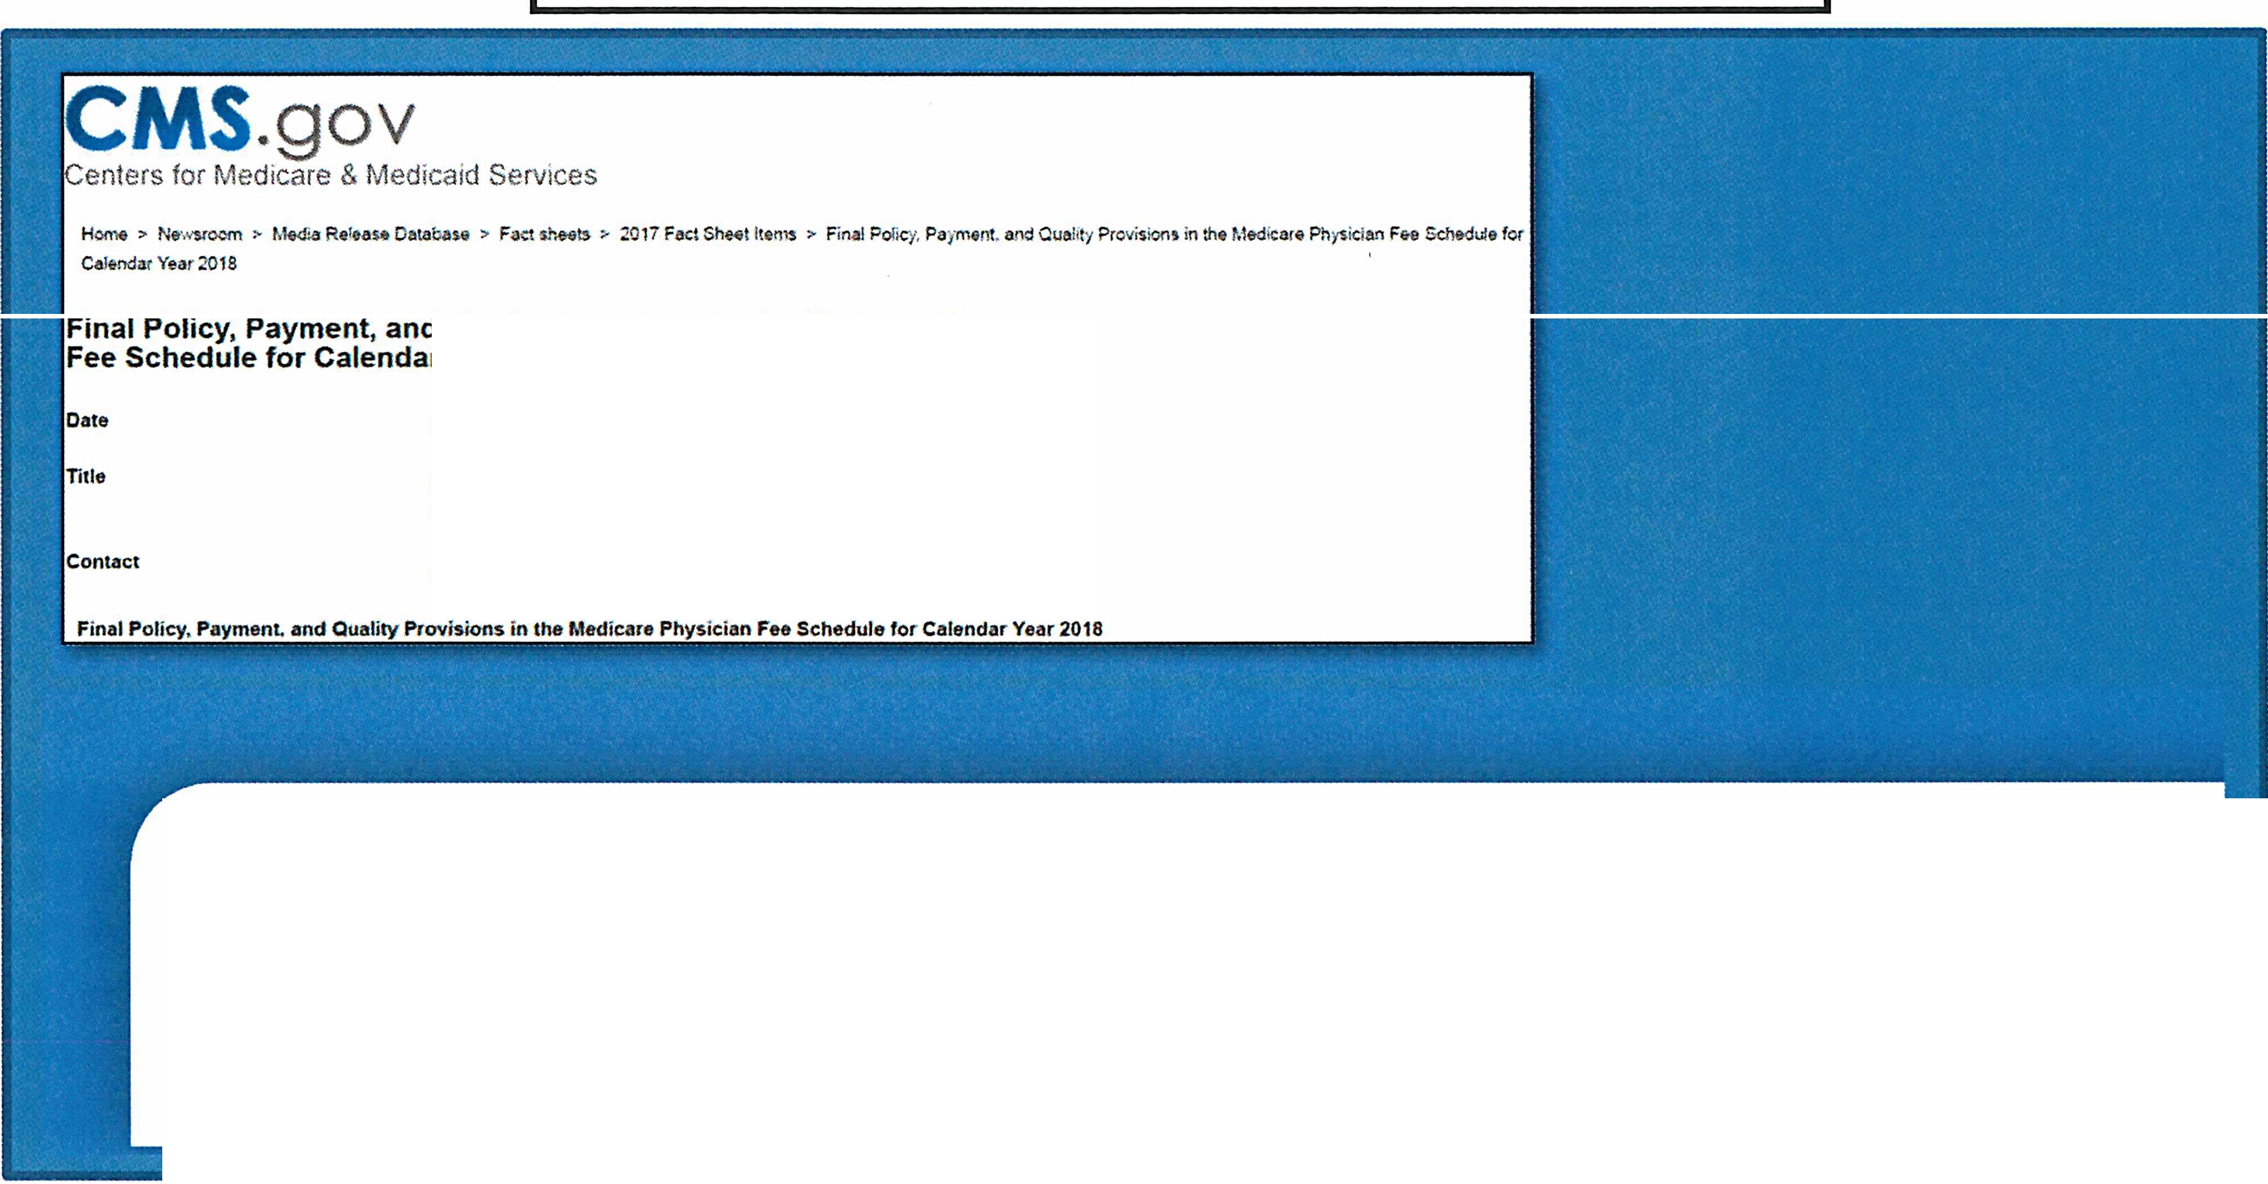

Practitioners who engage in remote monitoring of patient physiological data of eligible beneficiaries may count the time they spend reviewing the reported data towards the monthly minimum time for billing the CCM code, but cannot include the entire time the beneficiary spends under monitoring or wearing a

monitoring device .

Final Policy, Paymen t, and Quality Provisions in the Medicare Physici an Fee Schedu le for Calendar Year 2018

2017-11-02

Final Policy, Paymenl and Ou31ity Provisions in the Medicare Physician Fee

Sd'le-dule *for* C3tendar Year 2018

presS< cms.hhs.9ov

is currently working on codes that more accuratelydescribe remote patient monitoring. In the final rule, we are finalizing separate payment for CPT code 99091 (Collection and interpretation of physiologic data (e.g., ECG, blood pressure, glucose monitoring) digitally stored and/or transmitted by the patient and/or caregiver to the physician or other qualified health care professional, qualified by education, training, licensure/regulation (when applicable) requiring a minimum of

30 minutes of time, for 2018 pending anticipated changes in CPT coding.

Despite this explicit permission to use remote monitoring for delivery of Part B CCM services and as a stand-alone service, MAOs are required to submit ***as supplemental benefits*** use of remote access technologies, including enhanced disease management, remote access technologies and telemonitoring, which are all evidence based tools for care coordinat io n and care management.

CMS MAO instructions and policies and Medicare Part B coverage dramatically differ on chronic condition remote monit oring . While Part B clearly permits use of remote monitoring to conduct chronic care management AND provides reimbursement (as of 1/1/2018) for "collection and interpretation of stored patient data by a physician or qualified health professional" through CPT code 99091, MAOs are instructed through the Medicare Managed Care Manual that use of "Telemonitoring ", "Remote Access Technologies", and "Enhanced Disease Management" are examp les of supplemental benefit s4 . Simply

4 Centers for Medicare and Medicaid Services, Medicare Managed Care Manual, Chapter 4, Section 30.3

- Examples of Eligible Supplemental Benefits Section, accessed at: [https://www.cms.gov/Regulations­](http://www.cms.gov/Regulations) and-Guidance/ Guidance/ M an uals/ Downloads/ mc86c0 4.pdf

PERSONAL CONNECTED HEALTH ALLIANCE

Comments to CMS on "Advance Notice of Methodological Changes for Calendar Year (CY) 2019 for Medicare Advantage (MA) Capitation Rates, Part C and Part D Payment Policies and 2019 draft Call

Letter"

Page **12**

put, CMS requires MAOs to cover all Part A and B services5 and explicitly directs MAOs to classify

,

remote monitoring as supplemental benefits. Medicare Advantage policy conflicts with Medicare Part B fee for service coverage which provides reimbursement for CPT code 99091 as of January 1, 2018 AND for chronic care management enabled through remote monitoring.

***The Solution: Provide Direction to MAOs in Call Letter and Update Medicare Managed Care Manual*** To 'sync' MAO and Part B coverage policy, to permit MAOs to modernize without excessive administrative requirements, and, to promote innovation, 2019 bid submission instructions in the annual call letter should clarify that use of remote monitoring to monitor biophysical signs or to deliver chronic care management services is a basic benefit, just as the 2019 Call Letter did for "Coverage of Supervised Exercise Therapy (SET for Symptomatic Peripheral Artery Disease" (page 182).

In addition, we ask CMS to promptly revise Section 30.3 of the "Medicare Managed Care Manual, Chapter 4 - Benefits and Beneficiary Protections" through revision of the MAO manual, to strike enhanced disease management, remote access technologies AND telemonitoring as examples of supplemental benefits.

***Conclusion:***

It is vital to cover chronic condition remote patient when clinically indicated and appropriate. Currently these services are covered in traditional Medicare via CPT Code 99091, CCM, TCM, as well as improved focus on primary care and chronic disease management. BUT, they may only be covered in Medicare Advantage as a supplemental benefit. There is an extensive and growing body of clinical evidence supporting the use of remote access technology (including telemonitoring and remote patient monitoring) - to conduct disease/care management. This clinical evidence demonstrates both improved outcomes and reduced healthcare costs when used for monitoring chronic conditions, including hypertension, diabetes, COPD, asthma, heart failure and obesity. In fact, the clinical evidence for remote access technologies and telemonitoring should be available to all Medicare beneficiaries without additional premium payments, like all Part A and Part B benefits.

We appreciate your consideration of our request to clarify that remote monitoring is a MA basic benefit in the 2019 Call Letter AND revise the Medicare Managed Care Manual.

Sincerely,



Chair, Personal Connected Health Alliance Director Business Development Diabetes Care. Roche Diagnostics Corp. Inc.

Vice President

Personal Connected Health Alliance

5 Centers for Medicare and Medicaid Services, Medicare Managed Care Manual, Chapter 4, Section 10.2

- Basic Rule, accessed at: ht tp s:// [www.cms.gov/Regulat ions -and](http://www.cms.gov/Regulations-and) ­ Guidance/ Guidance/ M anua ls/ Downloads/ mc86c04 .pdf

PERSONAL CONNECTED HEALTH ALLIANCE

Comments to CMS on "Advance Notice of Methodological Changes for Calendar Year (CY) 2019 for Medicare Advantage (MA) Capitation Rates, Part C and Part D Payment Policies and 2019 draft Call

Letter" Page 13